**REPORT**

**ON**

**Tribute To**

**S.P.BALASUBRAHMANYAM**

**BY:**

**NAME :PARVATHI N K**

**USN:1CE17CS079**

**COLLEGE:CITY ENGINEERING COLLEGE**

**Overview of the Project:**

The “Tribute to S.P.BALASUBRAHMANYAM” is a webpage created about the legendry singer S.P.BALASUBRAHMANYAM. This webpage contains the a image of S.P.B which is aliened left and also include background of S.P.B,list of songs, movies acted, awards won.

**About S.P.B:**

* Panditaradhyula Balasubrahmanyam also referred to as S. P. B was an Indian musician, playback singer, music director, actor, dubbing artist, and film producer who worked predominantly in Telugu, Tamil, Kannada, Hindi, and Malayalam films.
* Balu was born on June 4th, 1946 in Konetampet, in present day Tamil Nadu, then in Andhra Pradesh. His father, Sri. S.P. Sambamurthy was a fine musician and an excellent exponent of “Harikatha” (a fine art form of entertainment combining music and storytelling). Balu took to singing early. Blessed with a rich melodious voice, a fine range and timbre drenched with honeydew the sprightly lad sang in public while pursuing his engineering diploma.
* While singing in one of the “talent-spotting contests” in Chennai, young Balu was spotted by the late film music composer, Sri. S.P. Kodandapani. Balu won the first prize and the enterprising music director gave the fresh talent a break to sing in the film “SRI SRI SRI MARYADA RAMANNA” (Telugu 1966).
* Widely regarded as one of the greatest singers of India, He won six National Film Awards for Best Male Playback Singer for his works in four different languages; Telugu, Tamil, Kannada, and Hindi.
* According to some sources, he held the Guinness World Record for recording the highest number of songs by a singer with over 40,000 songs. He recorded 21 songs in Kannada for the composer Upendra Kumar in Bangalore from 9 am to 9 pm on 8 February 1981.
* In addition, he recorded 19 songs in Tamil and 16 songs in Hindi in a day, which has also been called a record.
* Even when he talks, he seems to sing. In whatever language you’ve heard him, and whatever kind of song you love him for, there’s no way you wouldn’t have heard an S.P. Balasubrahmanyam song if you’re an Indian, because he’s sung more than 40,000!
* Despite a fabulous musical career spanning 49 years in the Telugu, Tamil, and Kannada, Hindi, and Malayalam film industries, SPB remains down to earth.

**Awards:**

* Padma Shri by Government of India
* Kala Pradarshini Ghantasala Puraskar
* Padma Bhushan by Government of India
* Filmfare Awards South [Won 3 times Best Male Playback Singer]
* Karnataka Rajyothsava Award by Government of Karnataka
* SIIMA Lifetime Achievement Award.

**Movies:**

* Muddina Mava [Kannada]
* Tirugu Bhana [Kannada]
* Shakti [Telugu]
* Mithunam [Telugu]
* Priyamaanavale [Tamil]
* Moone Moonu Varthai [Tamil]

**Tools Used:**

* **Hardware Requirements:**

**Processor :** Intel Core i7

**Memory :** 4GB RAM

**Keyboard :** QWERTY

* **Software Requirements:**

**Operating System:** Windows10

**Tools :** Visual Studio Code 2020, Chrome

**Languages :** HTML, CSS, JAVA Script

**Source Code:**

CODE FOR INDEX.HTML

<html>

<head>

  <title>Tribute to SPB</title>

  <meta charset="utf-8">

    <link rel="stylesheet" href="index.css">

</head>

<body>

  <section class="showcase">

    <header>

      <h2 class="logo"></h2>

      <div class="toggle"></div>

    </header>

    <video src="vid.mp4" muted loop autoplay></video>

    <div style="position: relative;">

        <img src="images/1.png" width="100%">

    </div>

    <div class="text" style="position: relative;">

      <h3>Tribute to</h3>

      <h3>S.P.Balasubrahmanyam</h3>

      <audio controls autoplay loop id="audio">

        <source src="Kelade Nimageega _ Geetha Movie Songs _ ilayaraja _ Shankar Nag _ Kannada Old Songs AETrim1616490596147.mp3" type="audio/mpeg">

          <p>If you can read this, your browser does not support the audio element.</p>

          </audio>

      </div>

</section>

  <div class="menu">

    <ul>

      <li><b><a href="index.html">Home</a></b></li>

      <li><b><a href="background.html">Background</a></b></li>

      <li><b><a href="songs.html">Songs</a></b></li>

      <li><b><a href="movies.html">Movies</a></b></li>

      <li><b><a href="awards.html">Awards</a></b></li>

    </ul>

  </div>

  <script>

      const menuToggle = document.querySelector('.toggle');

      const showcase = document.querySelector('.showcase');

      menuToggle.addEventListener('click', () => {

        menuToggle.classList.toggle('active');

        showcase.classList.toggle('active');

      })

  </script>

</body>

  </html>

CODE FOR BACKGROUND.HTML

<html>

<head>

  <title>Tribute to SPB</title>

  <meta charset="utf-8">

    <link rel="stylesheet" href="index.css">

</head>

<body>

  <section class="showcase">

    <header>

      <h2 class="logo"></h2>

      <div class="toggle"></div>

    </header>

    <video src="vid.mp4" muted loop autoplay></video>

    <div style="align-items:left">

       <div style="position:relative; text-align: center; ">

        <img  style=" background-size: cover;

        background-position: center;" src="images/4.png" width="100%" height="100%">

    </div>

    </div>

    <div class="text1" style="position: relative; ">

     <h2>S. P. BALASUBRAHMANYAM </h2>

        <h3>Singer . Actor . Music director . Dubbing artist . Film producer</h3>

        <p>Panditaradhyula Balasubrahmanyam also referred to as S. P. B was an Indian musician, playback

            singer, music director, actor, dubbing artist, and film producer who worked predominantly in Telugu, Tamil,

            Kannada, Hindi, and Malayalam films. Widely regarded as one of the greatest singers of India, He won six

            National Film Awards for Best Male Playback Singer for his works in four different languages; Telugu, Tamil,

            Kannada, and Hindi. According to some sources, he held the Guinness World Record for recording the highest

            number of songs by a singer with over 40,000 songs. He recorded 21 songs in Kannada for the composer Upendra

            Kumar in Bengaluru from 9 am to 9 pm on 8 February 1981. In addition, he recorded 19 songs in Tamil and 16

            songs in Hindi in a day, which has also been called a record.</p>

          <p>Even when he talks, he seems to sing. In whatever language you’ve heard him, and whatever kind of song you

            love him for, there’s no way you wouldn’t have heard an S.P. Balasubrahmanyam song if you’re an Indian,

            because he’s sung more than 40,000!.Despite a fabulous musical career spanning 49 years in the Telugu, Tamil,

            Kannada, Hindi, and Malayalam film industries, SPB remains down to earth.</p>

      </div>

</section>

<div class="menu">

  <ul>

    <li><a href="index.html">Home</a></li>

  </ul>

</div>

<script>

  const menuToggle = document.querySelector('.toggle');

  const showcase = document.querySelector('.showcase');

  menuToggle.addEventListener('click', () => {

    menuToggle.classList.toggle('active');

    showcase.classList.toggle('active');

  })

</script>

</body>

 </html>

CODE FOR SONGS.HTML

<html>

<head>

  <title>Tribute to SPB</title>

  <meta charset="utf-8">

    <link rel="stylesheet" href="index.css">

</head>

<body>

  <section class="showcase">

    <header>

      <h2 class="logo"></h2>

      <div class="toggle"></div>

    </header>

    <video src="vid.mp4" muted loop autoplay></video>

    <div style="align-items:left">

       <div style="position:relative; text-align: center; ">

        <img  style=" background-size: cover;

        background-position: center;" src="images/2.png" width="100%">

    </div>

    </div>

    <div class="text" style="position: relative; ">

      <h2>Famous Songs of S.P.B</h2>

         <p>Naguva Nayana [Pallavi Anu Pallavi - Kannada - 1983]</p>

         <p>Ee Bhoomi Bannada Buguri [Mahaakshatriya - Kannada - 2014]</p>

         <p>Ee Sundara [Amrutha Varshini - Kannada - 1996]</p>

         <p>Kaadhak Rojave [Roja - Tamil - 1992]</p>

         <p>En Kadhalae[Duet - Tamil - 1994]</p>

         <p>James Bond Super Power [Adayalam - Malayalam - 2021]</p>

         <p>Dil Deewana [Maine Pyar Kiya - Hindi - 1989]</p>

         <p>Suvvi Suvvi [Chuttalabbai - Telugu - 2015]</p>

       </div>

  </section>

  <div class="menu">

    <ul>

      <li><a href="index.html">Home</a></li>

    </ul>

  </div>

  <script>

    const menuToggle = document.querySelector('.toggle');

    const showcase = document.querySelector('.showcase');

    menuToggle.addEventListener('click', () => {

      menuToggle.classList.toggle('active');

      showcase.classList.toggle('active');

    })

  </script>

  </body>

  </html>

CODE FOR MOVIES.HTML

<html>

<head>

  <title>Tribute to SPB</title>

  <meta charset="utf-8">

    <link rel="stylesheet" href="index.css">

</head>

<body>

  <section class="showcase">

    <header>

      <h2 class="logo"></h2>

      <div class="toggle"></div>

    </header>

    <video src="vid.mp4" muted loop autoplay></video>

    <div style="align-items:left">

       <div style="position:relative; text-align: center; ">

        <img  style=" background-size: cover;

        background-position: center;" src="images/3.png" width="100%">

    </div>

    </div>

    <div class="text1" style="position: relative; ">

      <h2>Movies in S.P.B as actor</h2>

      <p>Muddina Mava [Kannada]</p>

      <p>Tirugu Bhana [Kannada]</p>

      <p>Priyamaanavale [Tamil]</p>

      <p>Moone Moonu Varthai [Tamil]</p>

      <p>Shakti [Telugu]</p>

      <p>Mithunam [Telugu]</p>

      </div>

  </section>

  <div class="menu">

    <ul>

      <li><a href="index.html">Home</a></li>

    </ul>

  </div>

  <script>

    const menuToggle = document.querySelector('.toggle');

    const showcase = document.querySelector('.showcase');

    menuToggle.addEventListener('click', () => {

      menuToggle.classList.toggle('active');

      showcase.classList.toggle('active');

    })

  </script>

  </body>

  </html>

CODE FOR AWARDS.HTML

<html>

<head>

  <title>Tribute to SPB</title>

  <meta charset="utf-8">

    <link rel="stylesheet" href="index.css">

</head>

<body>

  <section class="showcase">

    <header>

      <h2 class="logo"></h2>

      <div class="toggle"></div>

    </header>

    <video src="vid.mp4" muted loop autoplay></video>

    <div style="align-items:left">

       <div style="position:relative; text-align: center; ">

        <img  style=" background-size: cover;

        background-position: center;" src="images/5.png" width="100%">

    </div>

    </div>

    <div class="text" style="position: relative; ">

      <h2>Awards won by S.P.B</h2>

         <p>Padma Shri by Government of India</p>

         <p>Padma Bhushan by Government of India</p>

         <p>Karnataka Rajyothsava Award by Government of Karnataka</p>

         <p>Filmfare Awards South [Won 3 times Best Male Playback Singer]</p>

         <p>SIIMA Lifetime Achievement Award</p>

         <p>Kala Pradarshini Ghantasala Puraskar</p>

       </div>

  </section>

  <div class="menu">

    <ul>

      <li><b><a href="index.html">Home</a></b></li>

    </ul>

  </div>

  <script>

    const menuToggle = document.querySelector('.toggle');

    const showcase = document.querySelector('.showcase');

    menuToggle.addEventListener('click', () => {

      menuToggle.classList.toggle('active');

      showcase.classList.toggle('active');

    })

  </script>

  </body>

  </html>

CODE FOR INDEX.CSS

@import url('https://fonts.googleapis.com/css?family=Poppins:200,300,400,500,600,700,800,900&display=swap');

*

{

  margin: 0;

  padding: 0;

  box-sizing: border-box;

  font-family: 'Poppins', sans-serif;

  overflow: hidden;

}

header{

  position: absolute;

  top: 0;

  left: 0;

  width: 100%;

  padding: 40px 100px;

  z-index: 1000;

  display: flex;

  justify-content: space-between;

  align-items: center;

}

.toggle{

  position: relative;

  width: 60px;

  height: 60px;

  background: url(https://i.ibb.co/HrfVRcx/menu.png);

  background-repeat: no-repeat;

  background-size: 30px;

  background-position: center;

  cursor: pointer;

}

.toggle.active{

  background: url(https://i.ibb.co/rt3HybH/close.png);

  background-repeat: no-repeat;

  background-size: 25px;

  background-position: center;

  cursor: pointer;

}

.showcase{

  position: absolute;

  right: 0;

  width: 100%;

  min-height: 100vh;

  padding: 100px;

  display: flex;

  justify-content: space-between;

  align-items: center;

  background: #111;

  transition: 0.5s;

  z-index: 2;

}

.showcase.active{

  right: 300px;

}

.showcase video{

  position: absolute;

  top: 0;

  left: 0;

  width: 100%;

  height: 100%;

  object-fit: cover;

  opacity: 0.8;

}

.text{

  position: relative;

  z-index: 10;

}

.text h2

{

  font-size: xx-large;

  text-align: justify;

  font-weight: 800;

  color: #fff;

  line-height: 1em;

  padding: 2%;

  text-transform: uppercase;

}

.text h3{

font-family:cursive;

font-size: 4em;

font-weight: 700;

color: #fff;

line-height: 1em;

text-transform: uppercase;

}

.text p{

  font-size: 1.1em;

  color: #fff;

  margin: 20px 0;

  font-weight: 400;

  max-width: 700px;

}

.text a{

  display: inline-block;

  font-size: 1em;

  background: #fff;

  padding: 10px 30px;

  text-transform: uppercase;

  text-decoration: none;

  font-weight: 500;

  margin-top: 10px;

  color: #111;

  letter-spacing: 20px;

  transition: 0.2s;

}

.text a:hover{

  letter-spacing: 6px;

}

.menu{

  position: absolute;

  top: 0;

  right: 0;

  width: 300px;

  height: 100%;

  display: flex;

  justify-content: center;

  align-items: center;

}

.menu ul{

  position: relative;

}

.menu ul li{

  list-style: none;

}

.menu ul li a{

  text-decoration: none;

  font-size: 24px;

  color: #111;

}

.menu ul li a:hover{

  color: #ffe347;

}

@media (max-width: 991px){

  .showcase,

  .showcase header

  {

    padding: 40px;

  }

  .text h2

  {

    font-size: 3em;

  }

  .text h3

  {

    font-size: 2em;

  }

}

#audio{

    display: inline-flex;

    margin-right: auto;

    margin-left: auto;

    margin-top: 15px;

    align-items: center;

}

.text1 h2{

  font-size: xx-large;

  text-align: justify;

  font-weight: 800;

  color: #fff;

  line-height: 1em;

  text-transform: uppercase;

}

.text1 h3{

font-family:cursive;

font-size: 1em;

font-weight: 700;

color: #fff;

line-height: 1em;

text-transform: uppercase;

}

.text1 p

{

  font-size: 20px;

text-align: justify;

  color: #fff;

  margin: 20px 0;

  font-weight: 400;

  max-width: 700px;

}

**Output:**

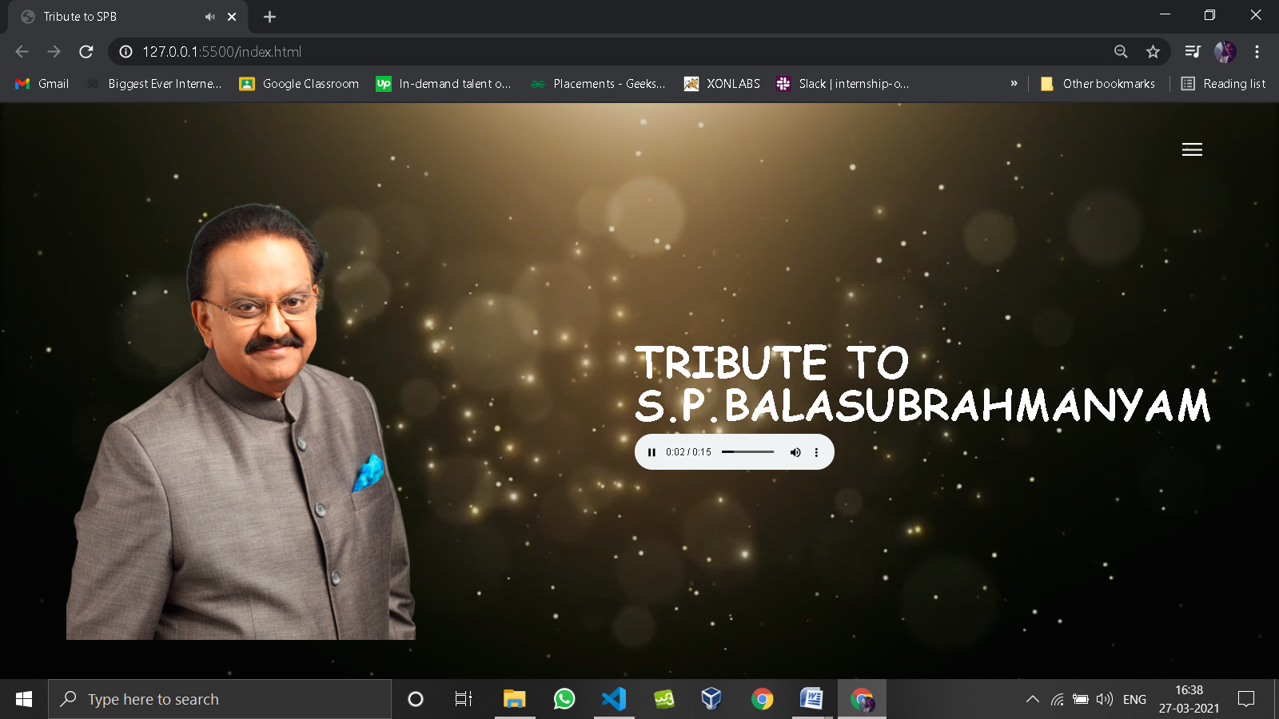

**FIG 1: Index page**

This is the tribute page which consist of S.P.B image and a audio song with video background

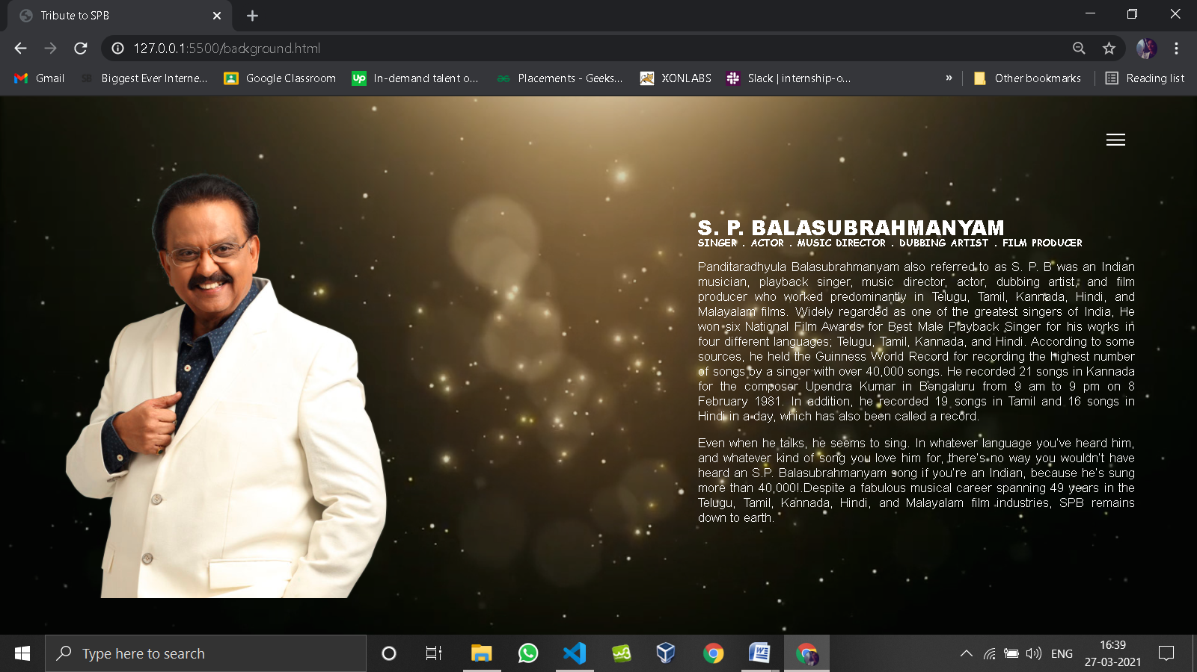

**FIG 2: Background page**

Background page consisting of details of S.P.B with his image.

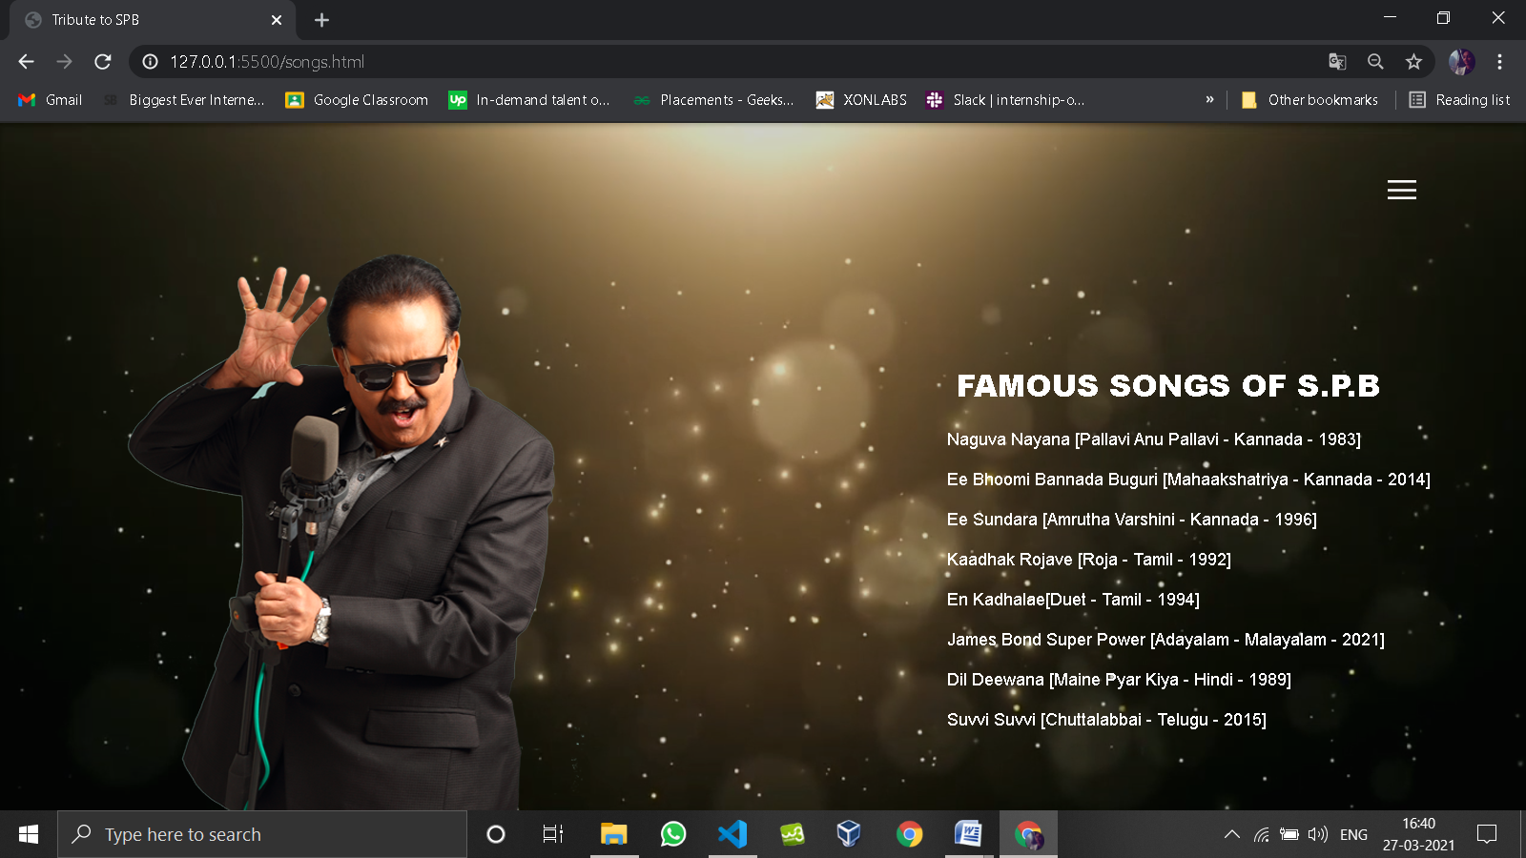

**FIG 3: List of Songs page**

This page consist of list of songs sung by S.P.B

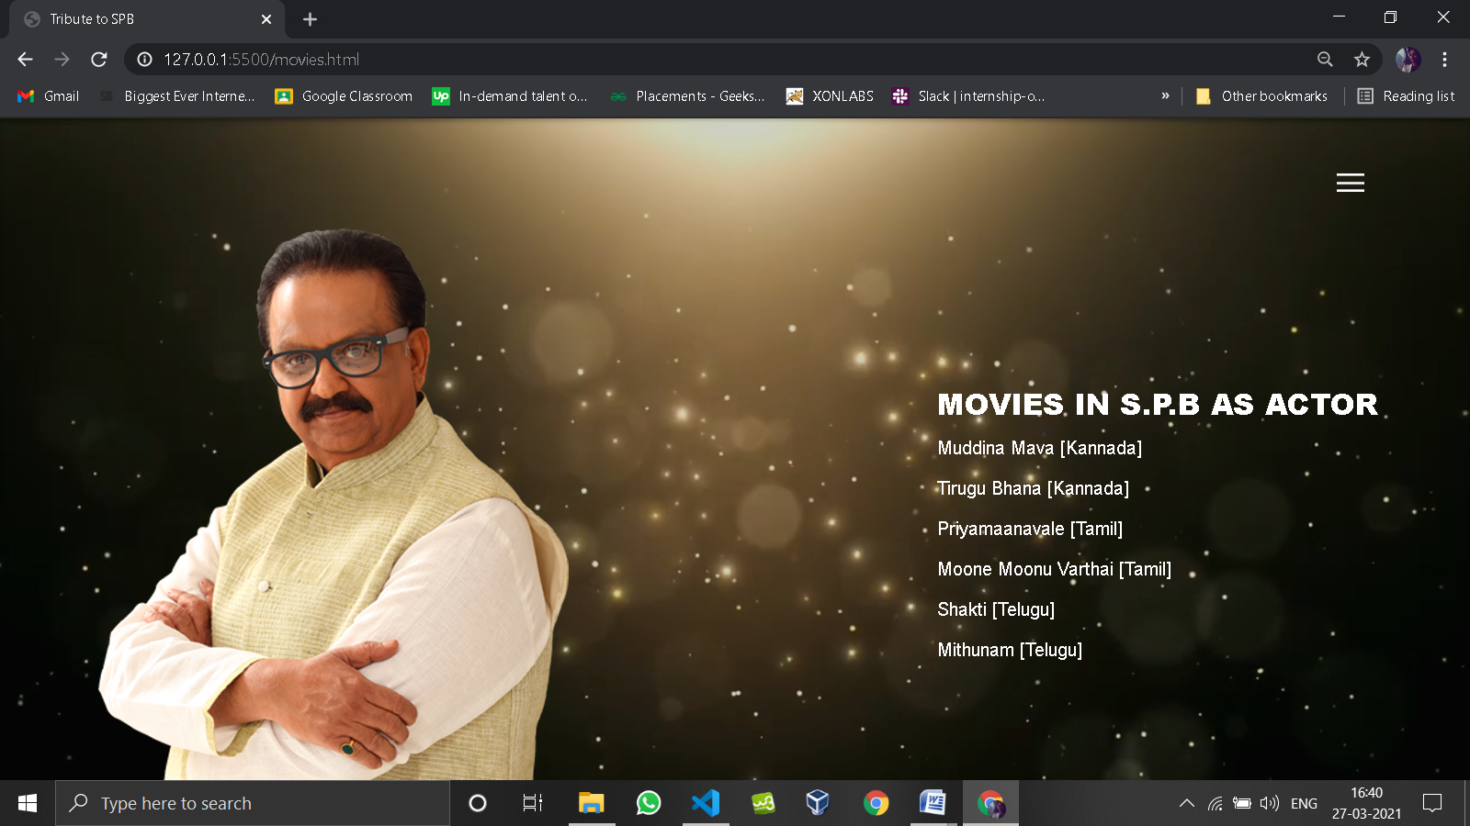

**FIG 4: List of Movies page**

Here it includes list of movies acted by S.P.B

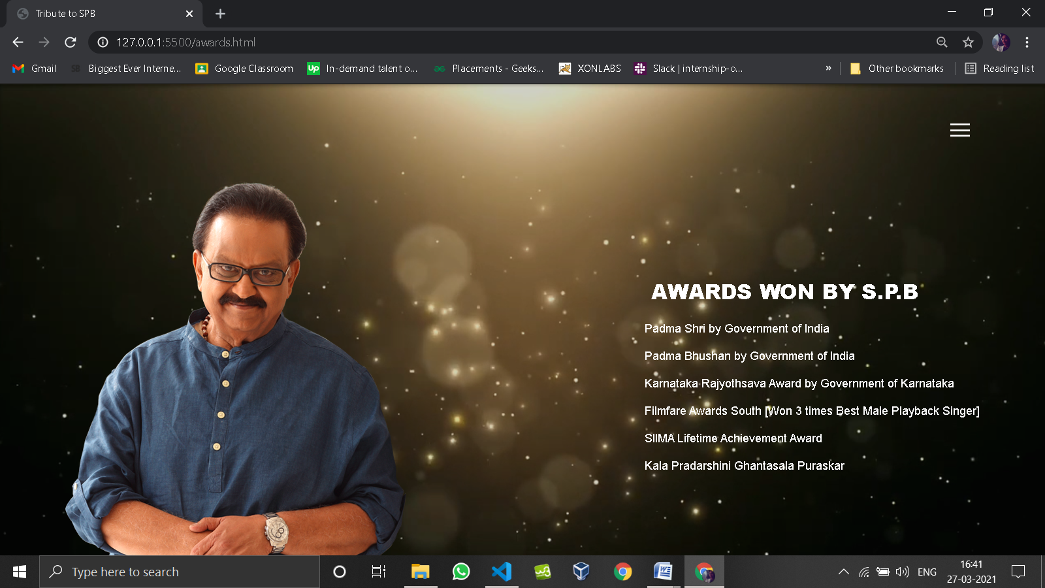

**FIG 5: List of Awards page**

This is the page which consist of list of awards with S.P.B image